Test Summary Report

1. Objective

2. Test Strategy

2.1 Test Scope

2.1.1 In Scope

2.1.2 Out scope

2.1.3 Assumption

2.2 Test Aproach

2.2.1 Positive Test cases

2.2.2 Negative test cases

2.3 Automation test approach

3. Test result summary

3.1 Article

3.2 Comment Article

3.3 Paginated lists of articles

3.4 Favourited articles

3.5 Follow users

4. Risks

5. Recommendation

6. Exit criteria

# **Test Summary Report**

# Objective

Document the test approach, summary test result of general functionalities for the ‘BBlog" social blogging site’ application

# Test Strategy

## Test Scope

### In Scope

Functional Testing and Automation testing for the following functions in Scope of Testing:

* CRUD Articles
* CR*D Comments on articles (no updating required)
* GET and display paginated lists of articles
* Favorite articles
* Follow other users

### Out scope

* Performance Testing
* Compatibility Testing
* DB Testing
* API testing

### Assumption

* Article: Title and content are required fields
* Display list posts of flowed users

## Test Aproach

* requirements-based criteria
* data-based criteria

### Positive Test cases

* **Articles:** User can create an article, update article, view article detail, delete article successfully
* **Comments on the article:** User can comment on a global post/personal post, view comment and delete comment successfully
* **GET and display paginated lists of articles:** Posts are paginated correctly: 10 posts on a page on Global Feed, Your Feed, My Post, Favourited Post screen
* **Favorite articles:** User can favorite and unfavorite article successfully
* **Follow other users**: User can follow and unfollow other users successfully

### Negative test cases

* **Articles:** Input invalid data for create/update the article
* **Comments on the article:** Input invalid data for comment on the article
* **GET and display paginated lists of articles:** check some unusual behavior such as: Switch between pages continuously
* **Favorite articles:** check some unusual behavior such as: Click favorite/unfavorite continuously
* **Follow other users**: check some unusual behavior such as: Click follow/unfollow continuously

Note: Detail test case check file test case

## Automation test approach

* Testing tool: playwright
* Test case selection for automation:
  + Test cases that cover the main function (happy case), priority is critical and there is no bug (stable test case):
    - Create an new article successfully
    - Update an article successfully
    - Delete an article
    - Delete a comment successfully
    - Verify that list posts on Global Feed are paginated correctly
  + Other test cases such as Test cases executed with different sets of data, The test case is going to be repeated could be automated later if QA has more time

# Test result summary

Detail Test result should be checked by file …:

* [Summary test result] sheet: containing test report for executing test cases
* [Bug report] sheet: containing bug report for failed test cases
* Other sheets: Containing detail manual test cases and test result for each functional

## Article

| Test Result | Number tcs |
| --- | --- |
| Failed | 10 |
| Passed | 13 |
| Blocked | 1 |
| Not start | 0 |
| Grand total | 24 |

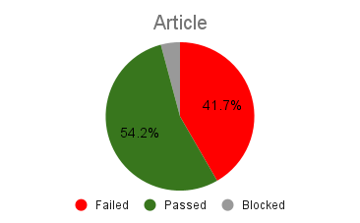

## Comment Article

| Test Result | Number tcs |
| --- | --- |
| Failed | 4 |
| Passed | 3 |
| Blocked | 2 |
| Not start | 0 |
| Grand total | 9 |

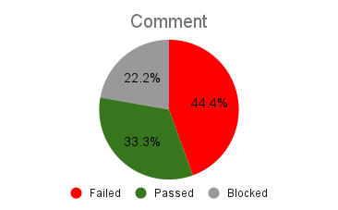

## Paginated lists of articles

| Test Result | Number tcs |
| --- | --- |
| Failed | 1 |
| Passed | 2 |
| Blocked | 3 |
| Not start | 0 |
| Grand total | 6 |

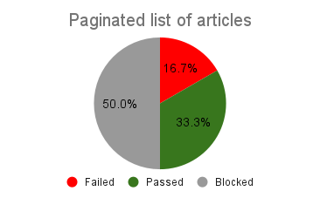

## Favourited articles

| Test Result | Number tcs |
| --- | --- |
| Failed | 3 |
| Passed | 0 |
| Blocked | 3 |
| Not start | 0 |
| Grand total | 6 |

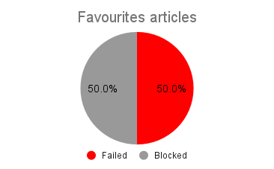

## Follow users

| Test Result | Number tcs |
| --- | --- |
| Failed | 1 |
| Passed | 2 |
| Blocked | 2 |
| Not start | 0 |
| Grand total | 5 |

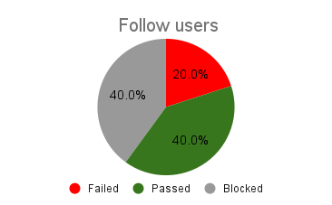

# Issue summary

| **Test Suites** | **Minor** | **Medium** | **Major** | **Critical** | **Total bugs** |
| --- | --- | --- | --- | --- | --- |
| Articles | 2 | 8 | 0 | 0 | 10 |
| Comment | 0 | 2 | 0 | 1 | 3 |
| Paginated lists of articles | 0 | 1 | 0 | 0 | 1 |
| Favourite articles | 0 | 0 | 0 | 2 | 2 |
| Follow users | 0 | 0 | 0 | 1 | 1 |
| **Total** | 2 | 11 | 0 | 4 | 17 |

# Risk

* DB is not accessible
* Lacking requirement, Need to use personal experience to design test cases

# Recommendation

* Performing test for 3 levels: the APIs, the Database, and the UI
* Automate the e2e testing flows required to be executed manually each time after a build
* Performing cross browser testing to ensure function work well on different browser

# Exit criteria

* + 1. All test cases should be executed
    2. All defects in Critical, Major, and Medium severity should be fixed and closed
    3. Any open defects in minor severity should be evaluated, and create plan fixing with expected dates of closure